**Functions**

**Function:** If a variable *y* depends on a variable *x* in such a way that each value of *x* determines exactly one value of *y*, then *y* is called a function of *x* and it is denoted by the following symbol,



where *x* is independent variable and *y* is dependent variable. The inverse of this function is denoted by .

**Example: $y=x^{2}+x+1$**; $y=sinx$; $y=e^{x}$; $y=lnx$ etc.

Alternatively, let  and  be two non empty sets. A mapping is called function if each element of  is assigned by unique element of .

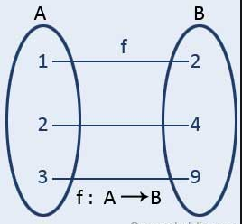 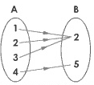 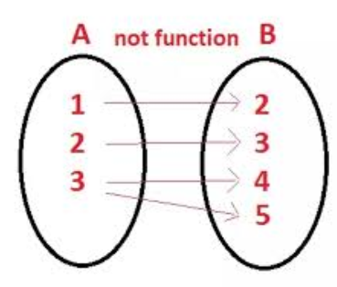

Function Function It is not function

**Types of functions:** There are many types of functions. These have been discussed as:

**Even function:** A function $y=f(x)$ is called an even function if it satisfies the condition

$f(-x)=f(x)$.

**Example: $y=cosx, y=x^{4}, etc.$** are even functions.

**Odd function:** A function $y=f\left(x\right)$ is called an odd function if it satisfies the condition

$f\left(-x\right)=-f(x)$.

**Example: $y=sinx, y=x^{3}, etc.$** are odd functions.

**One–one Function:** Let  map  into , i.e, . Then  is called a one-one function if different elements in  are assigned to different elements in , that is, if no two different elements in  have the same image. More briefly,  is one-one if  implies or, equivalently,  implies .



**Onto Function:** Let  be a function of into . Then  is called a onto function if every element of  appears as the image of at least one element of . More briefly,  is onto function if .



**Constant Function:** A function  of into is called a constant function if the same element in  is assigned to every element in . More briefly,  is a constant function if the range of  consists of only one element.

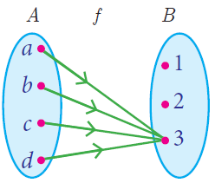

**Inverse Function:** Let  be a function of into . In general,  could consist of more than one element or might even be the empty set . Now if  is a one-one function and an onto function, then for each  the inverse  will consist of a single element in . We therefore have a rule that assigns to each  a unique element in . Accordingly,  is a function of  into  and we can write



In this situation, when  is one-one and onto, we call  the inverse function of .

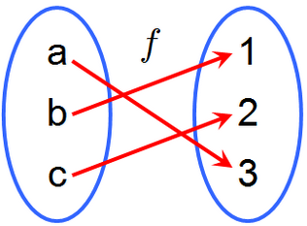 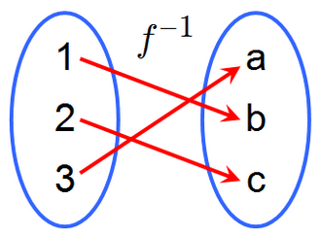

Function,  Inverse function, 

**Composition of Functions:** Let  be a function of into and  be a function of into . We illustrate the functions below,

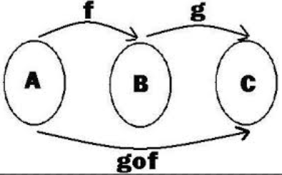

Let ; then its image  is in  which is the domain of . Accordingly, we can find the image of  under the mapping , that is, we can find . Thus we have a rule which assigns to each element a corresponding element . In other words, we have a function of  into . This new function is called product function or composition function of  and and it is denoted by

 or 

More briefly, and  then we define a function  by

.

**Domain:** The set of all values of *x* for which the function is defined, is called domain of the function. Simply domain is the set of all allowable *x*-values.

Mathematically, .

**Range:** The set of all values of *y* corresponding to the *x* values for which the function is defined, is called range of the function. Simply range is the set of all possible y-values.

Mathematically, .

**Interval:** If the set of all real numbers lie between two real numbers *a* and *b*, where $a ˂ b$ then the set of all real numbers is called an interval.

Intervals are four kinds:

1. The set $\{xϵR:a≤x≤b\}$ is called a closed interval, denoted by $[a,b]$.
2. The set $\{xϵR:a<x<b\}$ is called an open interval, denoted by $(a,b)$.
3. The set $\{xϵR:a<x≤b\}$ is called a left half open interval, denoted by $(a,b]$.
4. The set $\{xϵR:a≤x<b\}$ is called a right half open interval, denoted by $[a,b)$.

**Problem 01:** Find the domain and range of the function.

**Solution:** Given function is,



Here, *y* gives real values for all real values of *x*.

So, the domain of the given function is,



**Again,** we have,







Here, *x* gives real values for all real values of *y*.

So, the range of the given function is,

(Ans)

**H.W:**

Find the domain and range of the following functions

1.Ans:  and 

2. Ans:  and 

3. Ans:  and 

**Problem 02:** Find the domain and range of the function.

**Solution:** Given function is,



Here, *y* gives real values for all real values of *x*.

So, the domain of the given function is,



**Again,** we have





In the above equation the values of *x* will be real if and only if its *Discriminant.*

 ; []











Therefore the range of the given function is,

(Ans)

**Alternative way, For range** we have















Here, x is defined if





Therefore the range of the given function is,

(Ans)

**H.W:**

Find the domain and range of the following quadratic functions

1. Ans:  and 

2. Ans:  and 

4. Ans:  and 

5.Ans:  and 

6. Ans:  and 

7. Ans:  and 

**Problem 03:** Find the domain and range of the function.

**Solution:** Given function is,



Here, y is undefined if





So, y gives real values for all real values of x except.

Therefore, the domain of the given function is

.

Again we have,











Here, x is undefined if





So, *x* gives real values for all real values of y except.

Therefore, the range of the given function is

 (Ans)

**Problem 04:** Find the domain and range of the function.

**Solution:** Given function is,



Here, y is undefined if





So, y gives real values for all real values of x except.

Therefore, the domain of the given function is

.

Again we have,









Here, *x* is defined for all real values of *y* except 

Therefore, the range of the given function is

 (Ans)

**H.W:**

Find the domain and range of the following quadratic functions

1. Ans:  and 

2. Ans:  and 

3.Ans:  and 

4.Ans:  and 

5. Ans:

**Problem 05:** Find the domain and range of the function.

**Solution:** Given function is,



Here, y gives real values iff







Therefore, the domain of the given function is

.

Again,



The values of *y* in (1) are positive or zero,*i.e, $y≮0$*.

Now; $y≮0$. [Squaring both sides]

 ; $y≮0$.

 ; $y≮0$.

 ; $y≮0$.

Here, *x* is defined for .

Therefore, the range of the given function is



***(Ans).***

**Problem 06:**Find the domain and range of the function.

Solution: Given function is,



Here, y gives real values iff









Therefore, the domain of the given function is

.

**Again,** we have,



The values of y in (1) are negative or zero ,*i.e*, $y≯0$.

Now $;y≯0$ [Squaring both sides]







$;y≯0$

$;y≯0$

$;y≯0$

Here*, x* is defined for .

Therefore, the range of the given function is



**(Ans).**

**H.W:**

Find the domain and range of the following functions

1. Ans:  and 
2. Ans:  and 
3. Ans:  and 
4. Ans:  and 
5. Ans:  and 
6. Ans:  and 
7. Ans:  and 

**Problem 07:** Find the domain and range of the function.

**Solution:** Given function is,



Here, *y* gives real values iff,









This inequality is satisfied if



Therefore, the domain of the given function is,







**Again,** we have,



The values of *y* in (1) are positive or zero *i.e, , $y≮0.$*

Now, $;y≮0$ [Squaring both sides]





$;y≮0$

$;y≮0$

In the above equation the values of *x* will be real if and only if it’s *Discriminant.*

*i.e, $;y≮0$*[]









$;y≮0$

$;y≮0$

$;y≮0$

$;y≮0$

Here, *x* is defined for .

So the range of the given function is



**(Ans).**

**Problem 08:** Find the domain and range of the function.

**Solution:** Given function is,



Here, y gives real values iff,



This inequality is satisfied for all real values of *x*.

Therefore the domain of the given function is,

.

**Again,** we have,

… … (1)

The values of *y* in (1) are positive and lowest value is 1,*i.e, $y≮1.$*

Now  ; $y≮1$ [Squaring both sides]

 ; $y≮1$

 ; $y≮1$

In the above equation the values of *x* will be real if and only if its *Discriminant.*

i.e,; $y≮1$ []

; $y≮1$

; $y≮1$

; $y≮1$

Here, *x* is defined for all 



**(Ans).**

**Problem 09:** Find the domain and range of the function.

**Solution:** Given function is,



Here, y gives real values iff,





This inequality is satisfied if,



Therefore, the domain of the given function is,





**Again,** we have,

… … (1)

The values of *y* in (1) are positive and lowest value is zero ,*i.e, $y≮0$*.

Now ; $y≮0$ [Squaring both sides]

 ; $y≮0$

 ; $y≮0$

In the above equation the values of *x* will be real if and only if it’s *Discriminant.*

i.e,  ; $y≮0$ []

 ; $y≮0$

 ; $y≮0$ [Dividing by -4]

Here, *x* is defined for all 

Therefore the range of the given function is,



 (Ans.)

**H.W:**

Find the domain and range of the following functions

1. Ans:  and 
2. Ans:  and 
3. Ans:  and 
4. Ans:  and 
5. Ans:  and 
6. Ans:  and 
7. Ans:  and 
8. Ans:  and 

**Problem 10:** Find the domain and range of the function.

**Solution:** Given function is,



Here, *y* gives real values iff,







Therefore the domain of the given function is.



**Again**, we have,



The values of *y* in (1) are positive and lowest value is near to 0,*i.e,*.

Now,  ;

 ;

 ;

 ;

Here, *x*is defined for all .

Therefore the range of the given function is



**(Ans)**